What is DNS poisoning/Spoofing?
In a DNS cache poisoning attack, hackers alter a domain name system (DNS) to a “spoofed” DNS so that when a legitimate user goes to visit a website, instead of landing on their intended destination they actually end up at an entirely different site. Usually, this happens without users even knowing, as the fake sites are often made to look like the real ones.
Tools Used
- Windows VM
- Kali VM
- Ettercap
- Text editor

1. Find the IP address of your attacker machine
Since I’m doing this on my LAN, I can use my private IPv4 address, which I truncated from the ifconfig command for the purpose of this demonstration.
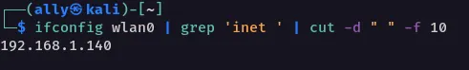

2. Create the landing page of your malicious website
Now, we’ll prepare the HTML file that the victim will encounter once the DNS has been spoofed. Since I’m using an Apache webserver, I’ll place the file in the root directory on my machine, which is /var/www/html. This is my file:

<title>No More Planting Trees</title>
<h1>No More Planting Trees</h1>
<h3>YouR CaR's ExteNDeD WarraNTy is AlMosT OuT</h3>
<p>Give me all your PII NOW or else your identity will be stolen !!! !!</p>
<form>
<label for="cc">Enter YouR CreDIT CarD Number ASAP <b>ASAP</b> !!:</label>
<input id="cc" placeholder="or else" />
</form>

I then changed the ownership of the file to the service account www-data.
sudo chown www-data ./index.html

3. Start Malicious Web Server
As stated previously, I’m using Apache, so I just started theapache2 service.
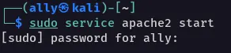

When I visit http://127.0.0.1/index.html, I see my malicious webpage.

4. Verify Website is Reachable from Victim Computer

Configuring Ettercap
#nano /etc/ettercap/etter.dns

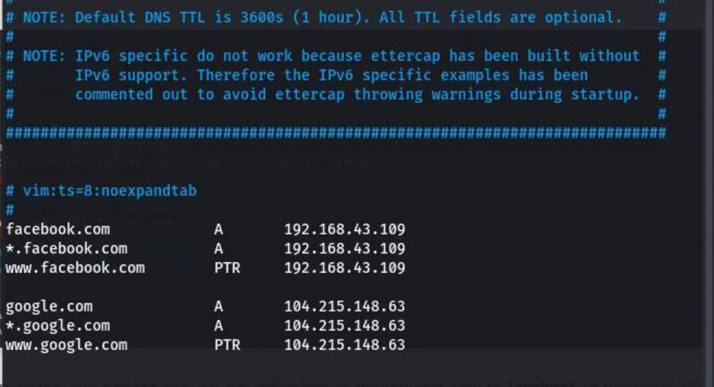

Now start Ettercap
# ettercap -G
2. Select the Primary Interface (eth0, wlan0….)
3. Scan the network click on the vertical three dots(.) then click on the Hosts after that click on Scan for hosts.
4. If scanning is completed then again click on the vertical three dots(.) then click on the Hosts after that click on Hosts list.
5. Click on the windows machine IP then click on the Add Target1 see below your host is added.
5. Click on the gateway IP then click on the Add Target2 see below your host is added.
6. then click on MITM menu >ARP Poisoning.
7. After that click on OK but Sniff remote connection must be enabled.
8. After ARP poisoning on victim the open the plugins
9. After opening the plugin, click on Manage Plugins, then select dns_spoof. Right-click on dns_spoof and click Activate.
Step : 5 Open your window machine

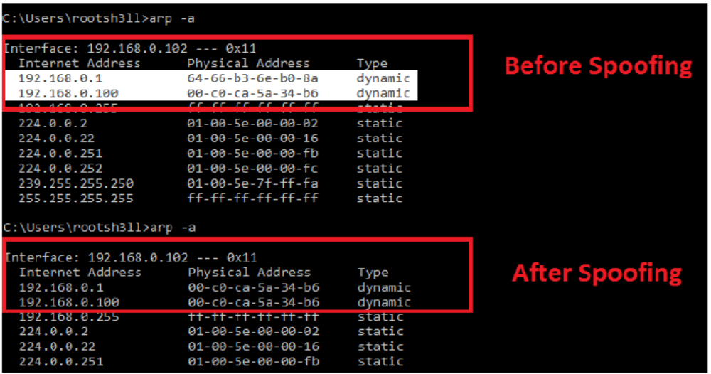

2nd Method
Dns Spoof using CLI Command
ettercap -T -i eth0 -M arp:remote -P dns_spoof /192.168.1.1// /192.168.1.33//

